A MINI PROJECT REPORT ON

**WEB SURVEY**

A dissertation submitted in partial fulfilment of the

Requirements for the award of the degree of

**BACHELOR OF TECHNOLOGY**

in

**INFORMATION TECHNOLOGY**

***Submitted by***

**N.Indu (16B81A1231)**

**A.Nikhitha (16B81A1247)**

**M.Pranitha (16B81A1253)**

***Under the esteemed guidance of***

**Mr. A.Seetharam Nagesh**

Sr.Assistant Professor, IT Department

CVR College of Engineering



**DEPARTMENT OF INFORMATION TECHNOLOGY**

**CVR COLLEGE OF ENGINEERING**

ACCREDITED BY NBA, AICTE & Affiliated to JNTU-H

Vastunagar, Mangalpally (V), Ibrahimpatnam (M), R.R. District, PIN-501 510

2019-2020

**DEPARTMENT OF INFORMATION TECHNOLOGY**

**CERTIFICATE**

This is to certify that the Project Report entitled **“Web Survey”** is a bonafide work done and submitted by **N.Indu (16B81A1231)**, **A.Nikhitha (16B81A1247)**, **M.Pranitha (16B81A1253)** during the academic year 2019-2020, in partial fulfilment of requirement for the award of Bachelor of Technology degree in Information Technology from Jawaharlal Nehru Technological University Hyderabad, is a bonafide record of work carried out by them under my guidance and supervision.

Certified further that to my best of the knowledge, the work in this dissertation has not been submitted to any other institution for the award of any degree or diploma.

**INTERNAL GUIDE** **HEAD OF THE DEPARTMENT**

**Mr.A.Seetharam Nagesh Dr.Bipin Bihari Jayasingh**

Sr.Assistant Professor, IT Department Professor, IT Department

**PROJECT COORDINATOR EXTERNAL EXAMINER**

**Mrs.G.Sunitha Rekha**

Assistant Professor, IT Department



**ACKNOWLEDGEMENT**

The satisfaction of completing this project would be incomplete without mentioning our gratitude towards all the people who have supported us. Constant guidance and encouragement have been instrumental in the completion of this project.

First and Foremost, We thank the Chairman, Principal, Vice Principal for availing infrastructural facilities to complete the mini project in time.

We offer our sincere gratitude to our internal guide **Mr.A.Seetharam Nagesh,** Sr.Assistant Professor, IT Department, CVR College of Engineering for his immense support, timely co-operation and valuable advice throughout the course of our project work.

We would like to thank the Head of Department, Professor **Dr. Bipin Bihari Jayasingh**, for his meticulous care and cooperation throughout the project work.

We are thankful to **Mrs.G.Sunitha Rekha,**Project Coordinator, Associate Professor, IT Department, CVR College of Engineering for his supportive guidelines and for having provided the necessary help for carrying forward this project without any obstacles and hindrances.

We also thank the **Project Review Committee Members** for their valuable suggestions.

**DECLARATION**

We hereby declare that the project report entitled “**Web Survey**” is an original work done and submitted to IT Department, CVR College of Engineering, affiliated to Jawaharlal Nehru Technological University Hyderabad, Hyderabad in partial fulfilment of the requirement for the award of Bachelor of Technology in **Information Technology** and it is a record of bonafide project work carried out by us under the guidance of **Mr.A.Seetharam Nagesh, Sr.Assistant Professor, Department of Information Technology.**

We further declare that the work reported in this project has not been submitted, either in part or in full, for the award of any other degree or diploma in this institute or any other Institute or University.

N.Indu - 16B81A1231

A.Nikitha - 16B81A1247

M.Pranitha - 16B81A1253

**Table of Contents**

PgNo

1. Introduction…………………………………………… 1
2. Software Requirement Specifications………………… 2
3. Design………………………………………………… 5
4. Implementation……………………………………….. 12
5. Testing………………………………………………… 25

Conclusion……………………………………………. 30

Future enhancements…………………………………. 31

References…………………………………………….. 32

Appendix A - Abbreviations………………………….. 33

Appendix B - Software Installation Procedure……….. 34

Appendix C - Software Usage Manual……………….. 40

**1.INTRODUCTION**

Web Surveys are defined as a data collection method where surveys are questionnaires are sent over the internet to a sample of respondents and they can respond to the survey .For a developer inorder to improve his applications functionality,feedback from the users is necessary as it becomes the faster medium to reach the target audience .Surveys have variety of purposes and can be carried out in many ways depending on methodology choosen and objectives to be achieved.

The users of this application are Survey Coordinators and Survey Respondents. Survey Coordinators can conduct the survey, analyse, develops and maintains survey datasets. And also they analyse survey data and provides timely reports appropriately, maintains results in relevant databases.

Survey Respondents complete surveys defined by Survey Coordinator. And he can cancel or submit the survey accordingly.

Results are displayed according to the survey type in the form of pie chart, line chart accordingly so that the understanding among the viewers becomes very easy.

**Literature Survey:**Generally in any survey application ,the survey can be created and every

user of the application can attempt the survey including the created user.But ,in our application ,the created user cannot attempt the survey that he created.We have used non-relational database and thus the user data and survey data are stored in JSON format which is light weight data interchange format.As we are taking the survey from many users , the data may be huge, so we use non-relational database which is a best way to deal with large amount of data.

**2. SOFTWARE REQUIREMENT SPECIFICATIONS**

**2.1 Software Requirements**

The software requirements needed for the project are

Operating System : Windows 10

Coding Language : MERN stack

IDE : Visual Studio

**2.2 Hardware Requirements**

The minimum hardware specifications to install and effectively operate are:

CPU type : Intel Core i5

RAM size : 4 GB

**2.3 Functional Requirements**

We have three modules in the project they are:

Create Survey and Attempt Survey

Retrieving Results

Mongo DB

**2.3.1 Create and Attempt Survey:**

Survey creation is done by Survey Coordinator. Survey Coordinator can create a survey by giving Survey Name, Survey Type, Date of creation, and the Questions. He can cancel or confirm survey accordingly.Any user can respond to the available survey except the one who created that survey.

**2.3.2 Survey Results:**

Results are displayed in a list form and graph form according to the survey type specified by user.Survey Respondents view the survey results in the form of line charts or bar charts and a list view.

**2.3.3 MongoDB:**

MongoDB is No SQL database. It is document database that provides high performance, high availability, and scalability. It is an open source product, developed and supported by a company named 10gen.

The need of MongoDB although there were many databases in action is because all the modern applications require big data, fast features development, flexible deployment, and the older database systems not competent enough, so the MongoDB has the major role.

MongoDB architecture is built on collections and documents. The basic unit of data in this database consists of a set of key-value pairs. It allows the documents to have different fields and structures. This database uses a document storage format called BSON which is a binary style of JSON documents.

MongoDB is non-relational database, field based, gives JavaScript client for querying and it is relatively easy to setup.

**2.4 Non-Functional Requirements:**

**Security -** Provides secure access to the users.

**Usability-** Easy to operate and attractive UI.

**Software Architecture:**

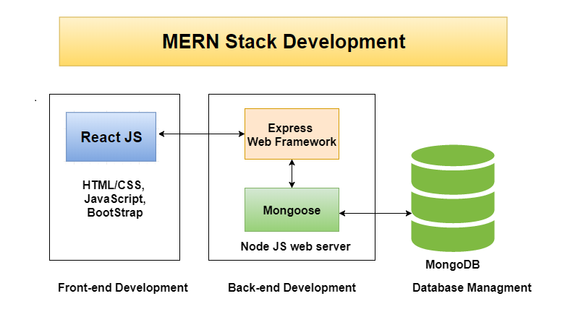

**3.DESIGN**

**UML Diagrams**

**UseCase Diagrams**

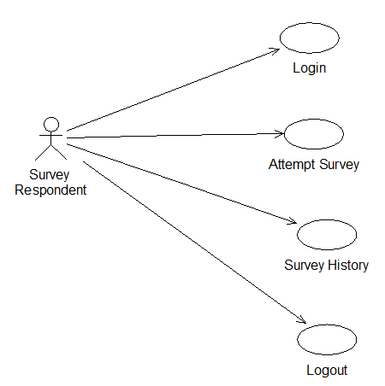

Fig 3.1.1 Use Case Diagram for Survey Respondent

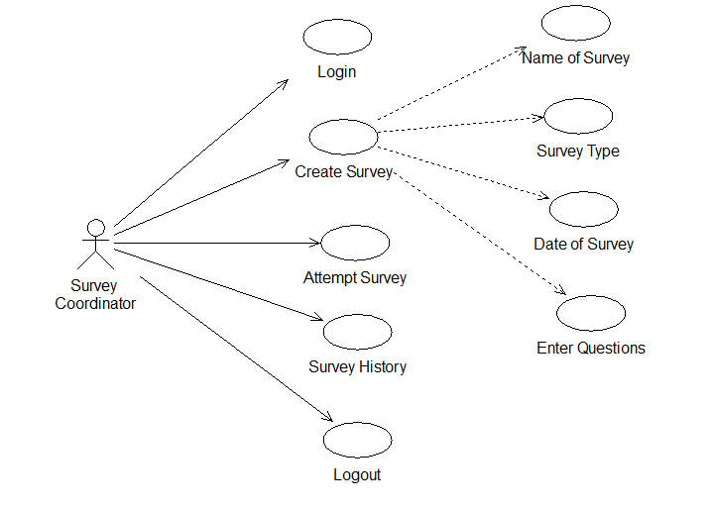

Fig 3.1.2 Use Case Diagram for Survey Coordinators

**Activity Diagram**

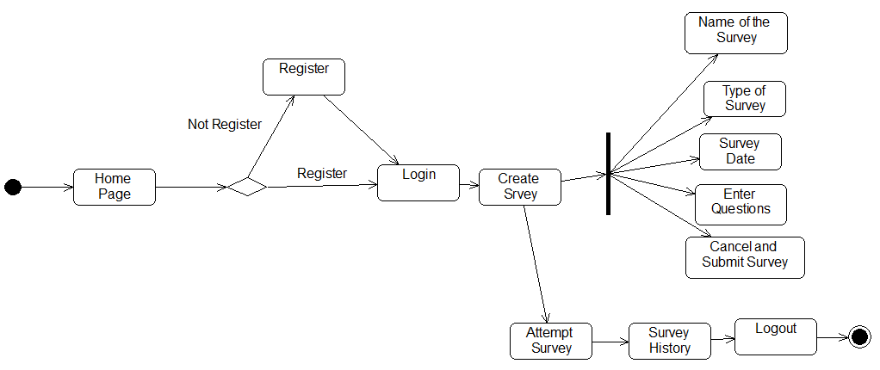

Fig 3.2.1 Activity Diagram for Survey Coordinators

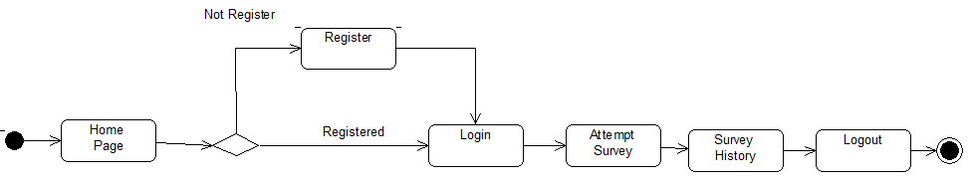

Fig 3.2.2 Activity Diagram for Survey Respondents

**Sequence Diagram**

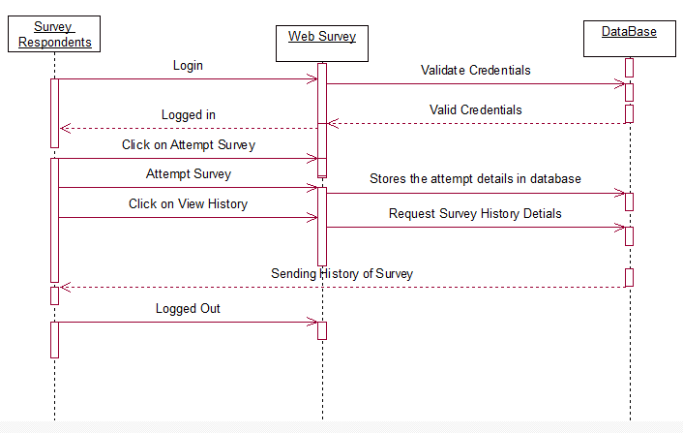

Fig 3.3.1 Sequence Diagram for Survey Respondents

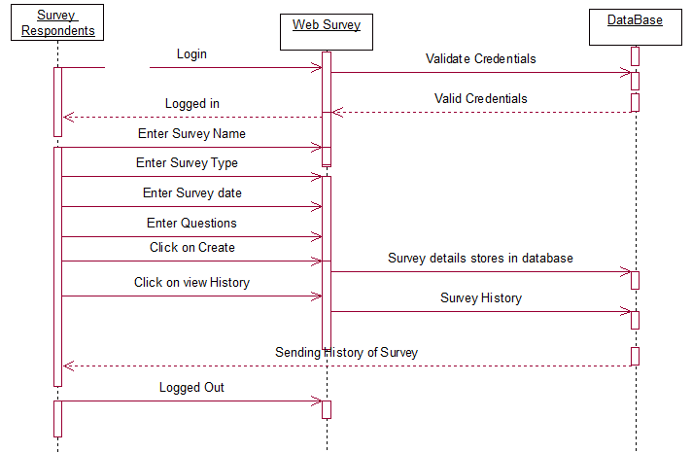

Fig 3.3.2 Sequence Diagram for Survey Coordinators

**Deployment Diagram:**

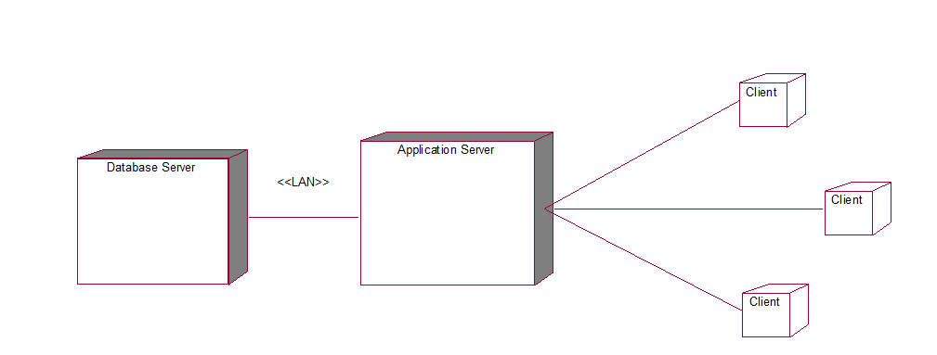

Fig.3.4.1 Deployment Diagram for Web Survey

**4.IMPLEMENTATION**

There are three modules Create and Attempt Survey,Retreiving Results and MongoDB.

Now let us discuss about their implementation.

**4.1** **Create Survey:**

Before Survey Coordinator creates the survey, he should have the account so that he can login, otherwise he should register and then have to login by giving email and password as credentials. Once he login into his account now he can able to create the survey. When he wants to create the survey, the necessary details need to be filled up are Survey Name, Survey Type, Date, Questions to be asked. Here Survey Name is meant to Name of the Survey, Survey Type meant to what is the type of the survey like education, product, etc. Date meant to on which date he is going to create the survey, and Questions meant to what are the questions to be asked on that respective survey type. If the Survey Coordinator has created any surveys, they are listed on the Create Survey page. He also attempts the survey when the surveys are created by others. He cannot attempt the survey which is created by himself. He can create or can cancel the survey.

**Code:**

**Create Survey**

modalConfirmHandler = () => {

if (

survey_name.trim().length === 0 ||

survey_type.trim().length === 0 ||

date.trim().length === 0

) {

return;

}

const survey = {

survey_name,

survey_type,

date,

qsn1,

qsn2,

qsn3

};

console.log(survey);

const requestBody = {

query: `

mutation CreateSurvey($survey_name: String!, $survey_type: String!, $date: String!, $qsn1:String,$qsn2:String,$qsn3:String){

createSurvey(surveyInput: {survey_name: $survey_name, survey_type: $survey_type, date: $date,qsn1:$qsn1,qsn2:$qsn2,qsn3:$qsn3}) {

_id

survey_name

survey_type

date

qsn1

qsn2

qsn3

}

}

` ,

variables: {

survey_name: survey_name,

survey_type: survey_type,

date: date,

qsn1: qsn1,

qsn2: qsn2,

qsn3: qsn3

}

};

**4.2 Attempt Survey:**

Once the Survey Coordinator creates the survey, Survey Respondents can attempt it if and only if he is logged in. Even if he tries to attempt the survey the popup will be appeared on the screen saying that please login to attempt the survey. Within the create survey page there the surveys which are already created and now Survey Respondents can attempt any of the surveys. He can give his feedback to the corresponding questions which are created by the Survey Coordinator. When the Survey Coordinator creates the survey on a particular day, Survey Respondents can attempt the survey only on that particular day. He can also attempt or cancel the survey.

**Code:**

**Attempt Survey**

fetchAttempts = () => {

this.setState({ isLoading: true });

const requestBody = {

query: `

query {

attempts {

_id

createdAt

survey {

_id

survey_name

date

}

}

}

`

};

**4.3 Results:**

Resultsaredivided intotwo components. First one is list which contains attempted survey details. Second is statistics of survey. Depending on the survey type given by the Survey Coordinator the count gets incremented by 1 internally if the Survey Type matches with the current one. Otherwise count will remains same when it was previous. Based on the final result count the results are displayed in the form of Line, Pie charts.

**Code:**

**Results**

changeOutputTypeHandler = outputType => {

if (outputType === "list") {

this.setState({ outputType: "list" });

} else {

this.setState({ outputType: "chart" });

}

};

**MongoDB:** Frontend (React) and backend(MongoDB) is connected using Graphql .

**Code:**

const uri = process.env.ATLAS_URI;

mongoose.connect(uri, { useNewUrlParser: true, useCreateIndex: true });

const connection = mongoose.connection;

connection.once("open", () => {

console.log("MongoDB database connection established successfully");

});

app.listen(port, () => {

console.log(`Server is running on port: ${port}`);

});

**4.4 Tools:**

The tools used in the development of the project, is:

**Visual Studio Code:** Visual Studio Code is a source-code editor developed by Microsoft for Windows, Linux, and macOS. It includes support for debugging, embedded Git control and GitHub, syntax highlighting, intelligent code completion, snippets, and code refactoring. It is highly customizable, allowing users to change the theme, keyboard shortcuts, preferences, and install extensions that add additional functionality. The source code is free and open source and released under the permissive MIT License.

**4.5 Technologies:**

**1. HTML 5:** HTML (HyperText Markup Language) is the most basic building block of the Web. It defines the meaning and structure of web content. Other technologies besides HTML are generally used to describe a web page's appearance/presentation (CSS) or functionality/behavior (JavaScript).

**2. CSS 3:** Cascading Style Sheets (CSS) is a stylesheet language used to describe the presentation of a document written in HTML or XML (including XML dialects such as SVG, MathML or XHTML). CSS describes how elements should be rendered on screen, on paper, in speech, or on other media.

**3. MERN Stack:** MongoDB is an open source database management system (DBMS) that uses a document-oriented database model which supports various forms of data. It is one of numerous nonrelational [database](https://searchsqlserver.techtarget.com/definition/database) technologies which arose in the mid-2000s under the [NoSQL](https://searchdatamanagement.techtarget.com/definition/NoSQL-Not-Only-SQL) banner for use in big data applications and other processing jobs involving data that doesn't fit well in a rigid relational model. Instead of using [tables](https://whatis.techtarget.com/definition/table) and [rows](https://searchoracle.techtarget.com/definition/row) as in [relational databases](https://searchdatamanagement.techtarget.com/definition/relational-database), the MongoDB architecture is made up of collections and documents.

React is a front-end library developed by Facebook. It is used for handling the view layer for web and mobile apps. ReactJS allows us to create reusable UI components. It is currently one of the most popular JavaScript libraries and has a strong foundation and large community behind it.

**5.TESTING**

Testingisdefined as an activity to check whether the actual results match the expected results and to ensure that the software system is free. It involves execution of a software component or system component to evaluate one or more properties of interest.

Testing also helps to identify errors, gaps or missing requirements in contrary to the actual requirements.

**5.1 Testing on different Surveys:**

Here the details of the user is entered and the database validates the user details.

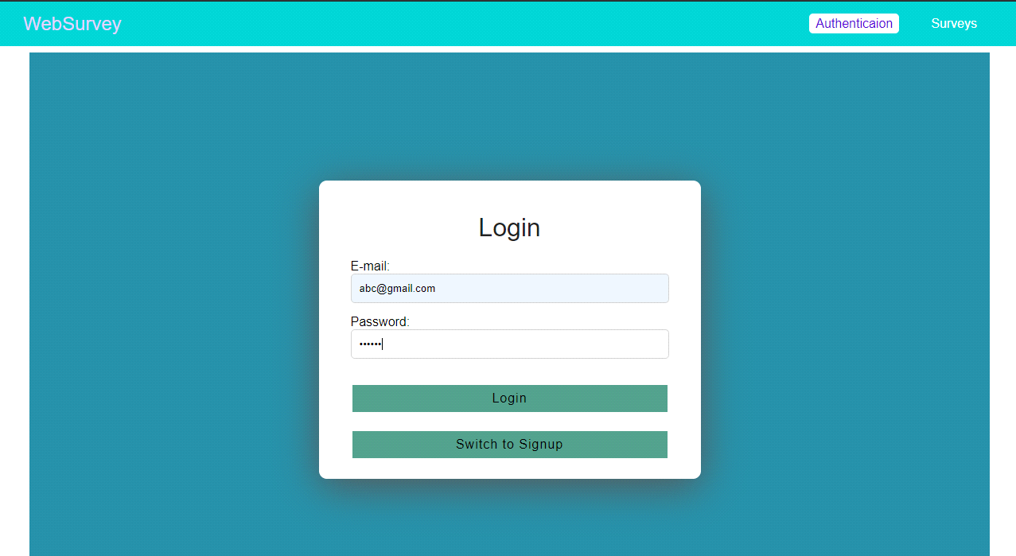

Fig 5.1.1 Login or Signup

If the user details doesn’t exist in the database , it’ll show a alert as shown below:

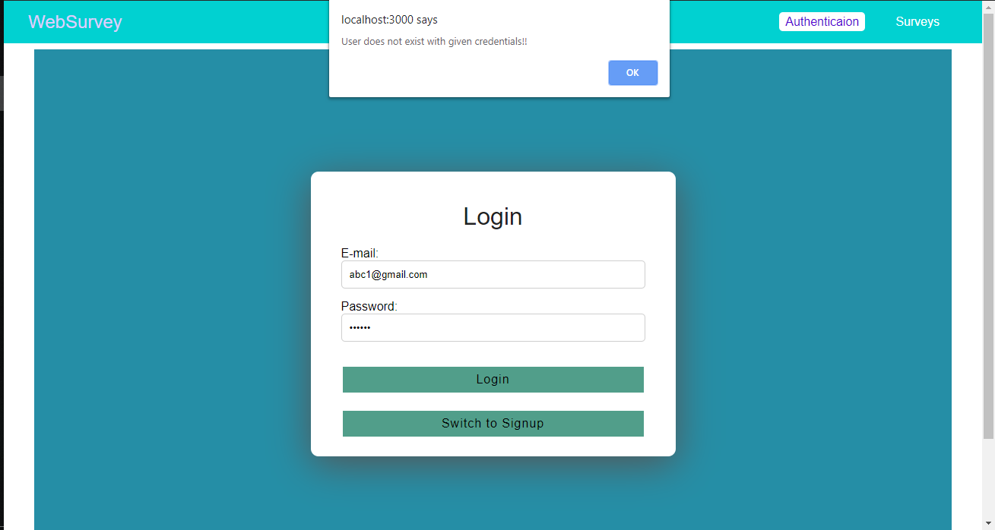

Fig.5.1.2 Invalid user

After validating the user details , the below page is displayed:

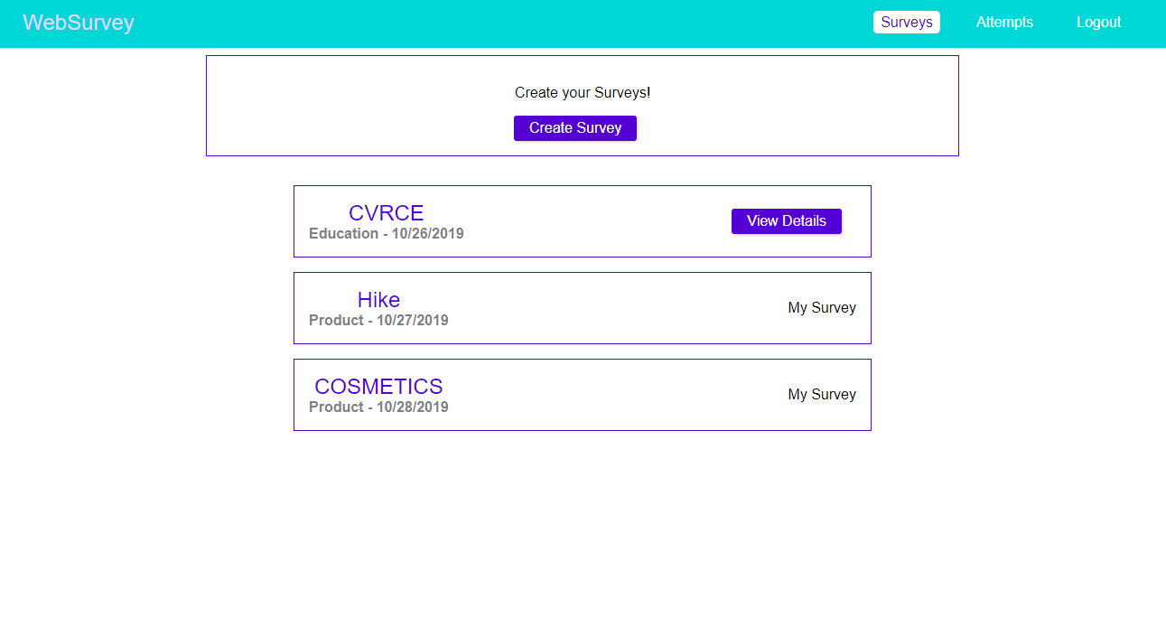

Fig 5.1.3 Survey Creation

Now the user gives the survey details as shown below:

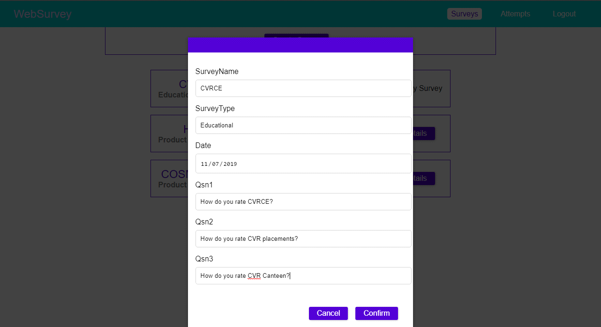

Fig 5.1.4 Survey Details

Survey got created which is shown below :

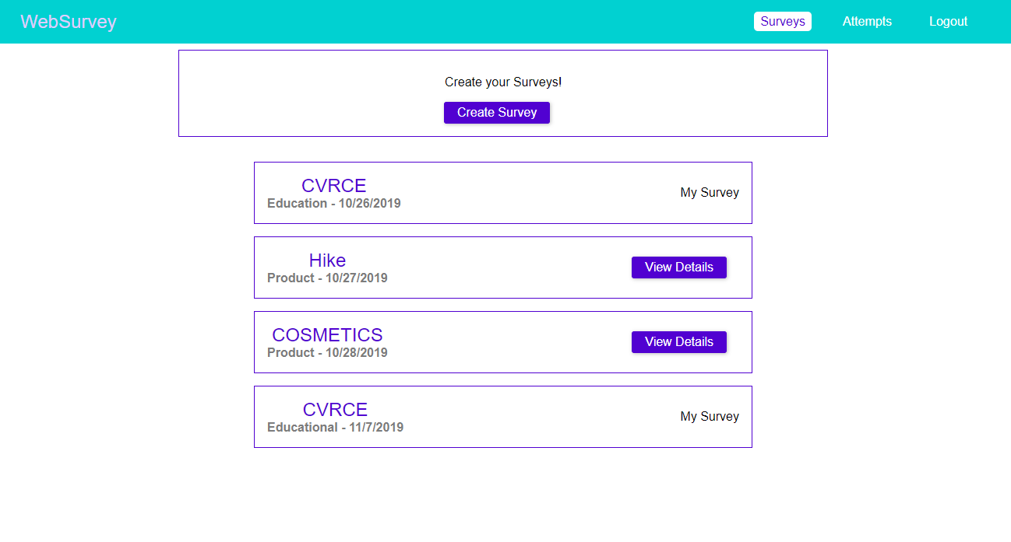

Fig.5.1.5 Created Survey list

* Attempting Survey : User attempts the survey as shown:

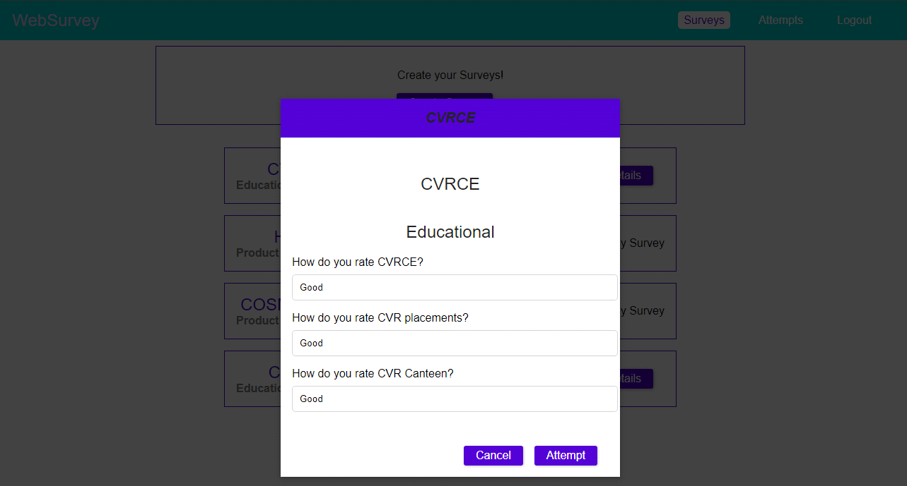

Fig 5.1.6 Attempt Survey

* Attempted Survey Details

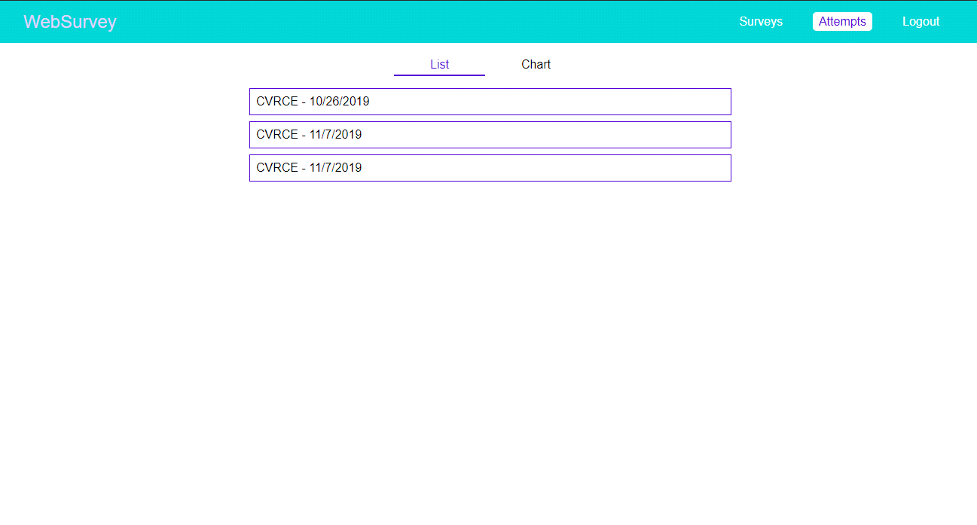

Fig 5.1.7 List of attempted surveys

**Storing the data in the database and retrieving results**

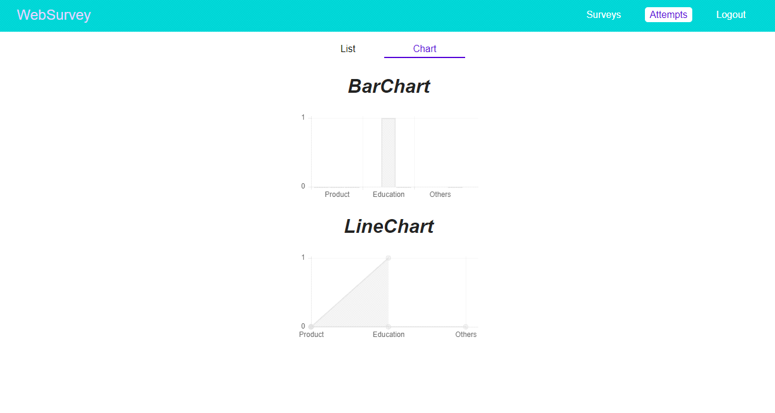

Fig 5.1.8 Results

**CONCLUSION**

As this project is an online based survey where an online link is given so that it will be very helpful for creating and attempting the survey. An Online Survey is a questionnaire that the target audience can complete over the Internet. Online Surveys are usually created as web forms with a database to store the answers and statistical software to provide analytics. People are often encouraged to complete online surveys by an incentive such as being entered to win a prize.

Companies often use online surveys to gain a deeper understanding of their customer’s tastes and opinions. Like traditional surveys, online can be used in two basic ways: To provide more data on customers, including everything from basic demographic information(age, education level and so on) to social data(causes, clubs, or activities the customer supports) To create a survey about a specific product, service or brand in order to find out how consumers are reacting to it. In contrast to traditional surveys, Online Surveys offer companies a way to sample a broader audience at a lower cost.

**FUTURE ENHANCEMENTS**

* Now the user can create the survey with limited number of questions .So, we can enhance it to give the no. of questions dynamically.
* Survey Coordinator can only give the text box for taking the respondents answer.We can modify it and make him to give result in his choice of type.
* Results of a particular survey should be displayed to every user.

**References**

1. <https://www.javatpoint.com/mongodb-tutorial>
2. <https://www.javatpoint.com/reactjs-tutorial>
3. <https://www.youtube.com/watch?v=QFaFIcGhPoM>
4. <https://www.w3schools.com/react/>
5. <https://medium.com/@rajaraodv/securing-react-redux-apps-with-jwt-tokens-fcfe81356ea0>

[6]<https://medium.com/the-ideal-system/graphql-and-mongodb-a-quick-example-34643e637e49>

**Appendix A – Abbreviations**

* **HTML** - HyperText Markup Language
* **CSS -** Cascading Style Sheets
* **MERN -**MongoDB ExpressJS ReactJS NodeJS
* **JWT** -JSON Web Token

**Appendix B – Software Installation**

**Visual Studio Code – How to download and install VSC**

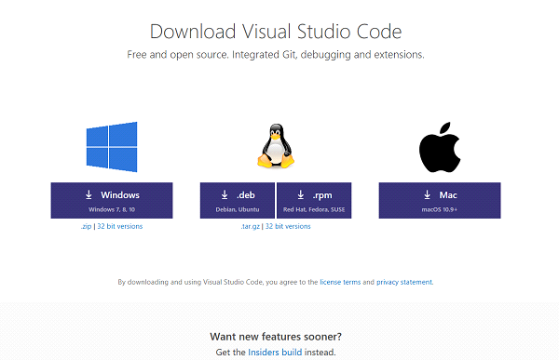

**Downloading Visual Studio Code:**

Downloading both the versions of Visual Studio Code is pretty simple. You just need to [head to this webpage](https://code.visualstudio.com/Download) dedicated to downloads of Visual Studio Code and choose the package that matches your needs and requirements.

As we can see in the screenshot above, it supports Windows 7, Windows 8, Windows 8.1 and Windows 10 for Windows platform. We can download a**.deb** file for Debian and Ubuntu and **.rpm** file for Red Hat, Fedora and SUSE. We can also get an x32 version or 32-bit version of the software for the operating systems just mentioned and obviously the **.zip** and **.tar.gz** archives for Windows and Linux respectively.

**Installing Visual Studio Code:**

After hitting the download button for the package that matches your needs and configuration the most, the package will start downloading on your machine. Now, there are different ways to install this software on different operating system environments. We will concentrate on how to install it on **Windows**. I am using Windows 10 to install it.

So, now after you downloaded a file named as *VSCodeSetup-version.exe*, double-click on the file to install it. It will just take about a minute to install depending on how powerful hardware you are running.

You will now get a UAC or User Account Control Prompt to which you will have to hit *Yes.*

Then you will see a window like this-

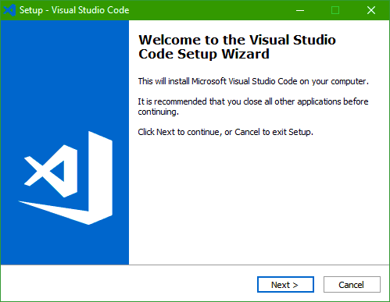

Now, hit *Next*to proceed further.

Then you will see the License Agreement page which will look like this-

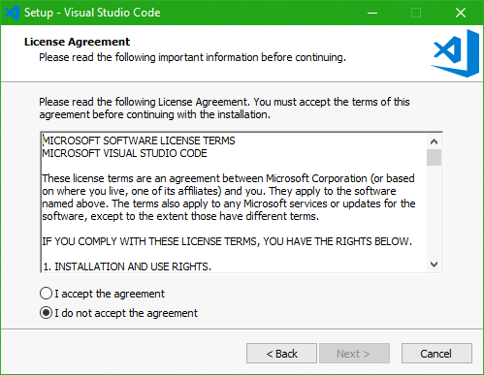  
Click on the *I accept the agreement*radio button and then hit *Next.*

Then you will see a page that will ask and show the default path where Visual Studio Code will be installed. By default it is set to *C:\Program Files\Microsoft VS Code*but in case you want, you can change it to your custom and desired location too.  
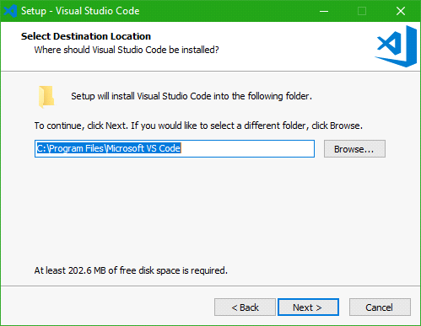

Now hit *Next*to proceed further.

Now the page will ask you if you want to create a Start Menu folder entry for Visual Studio Code. According to your preferences, you can now select if you want to or not create a start menu entry for VS Code.

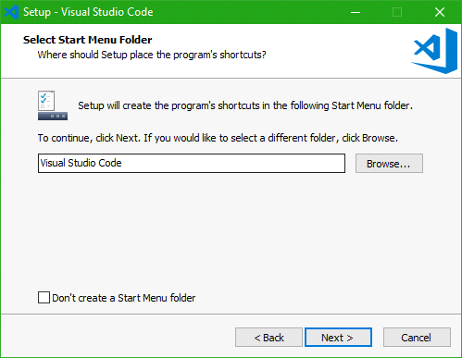

After hitting the *Next*button, the next page will show you some additional options as shown in the screenshot below that you can choose. After you are done, hit *Next.*

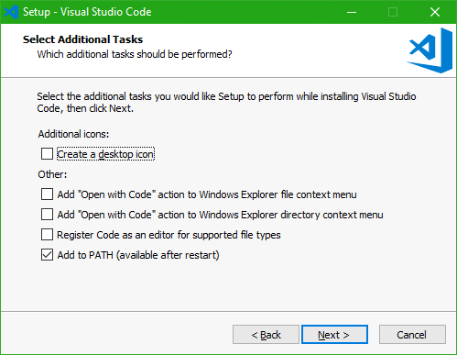

Then it will show you a summary of what preference you have selected to install VS Code, and according to that you can navigate either way and proceed with the installation by hitting the *Install*button.

Now, it will show an installation progress bar. After the installation is done, hit *Finish*to launch start using Visual Studio Code.

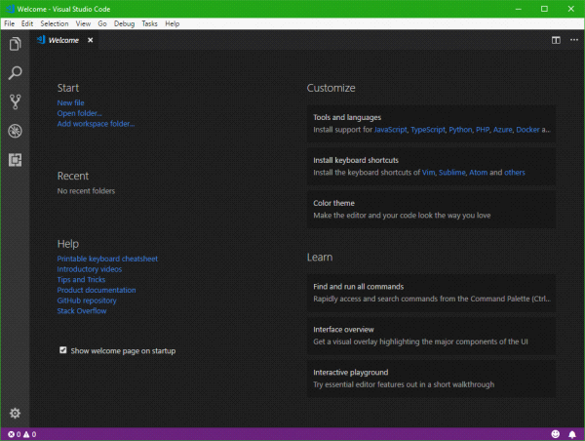  
Now, this is the home page of a fresh instance of Visual Studio Code. You can create new projects or use your existing project folders. A wide variety of useful extensions are available for the IDE for you to be productive.

**Step by step commands to install node in visual studio code :**

1.Download the Windows installer from Nodejs.org

2.Run the installer ,follow the prompts in the installer ,Restart your computer .

3.Test the Node using node -v command in vscode terminal.

4.Test npm using npm -v,if it is installed it displays npm version else throws an error.

**Step by step commands to install express  in visual studio code :**

1.Check whether Node.js module is available

2.If it is available run npm install express command in the vscode terminal.

3.In order to check whether express is installed or not ,use command npm express -v which displays express.js version

**Step by step commands to install react in visual studio code :**

      1.  Open terminal (ctrl+`)

      2.   Use the command : npx create-react-app  <app-name>.

      3.   Delete all the source files.

      4.   Add index.css files and index.js files in src folder.

      5.   Run the project using npm start command.

      6.   To install bootstrap use the command : npm install  react-bootstrap bootstrap

**Step by step procedure  to connect mongodb atlas with  node js:**

1.Create mongodb atlas account.

     2. Add mongodb atlas cluster by clicking on “build new cluster’ button.

     3.whitelist your ip address of your machine.

     4.Copy the connection string which is found by pressing on ‘connect’ button 

5.Create a  new js file and copy the connection string

     6.Createjs files to define Database Schemas.

**Appendix C – Software Usage Manual**

Here we'll let to know how to use our software.First the user has to login or register into the application.The below page will be displayed.

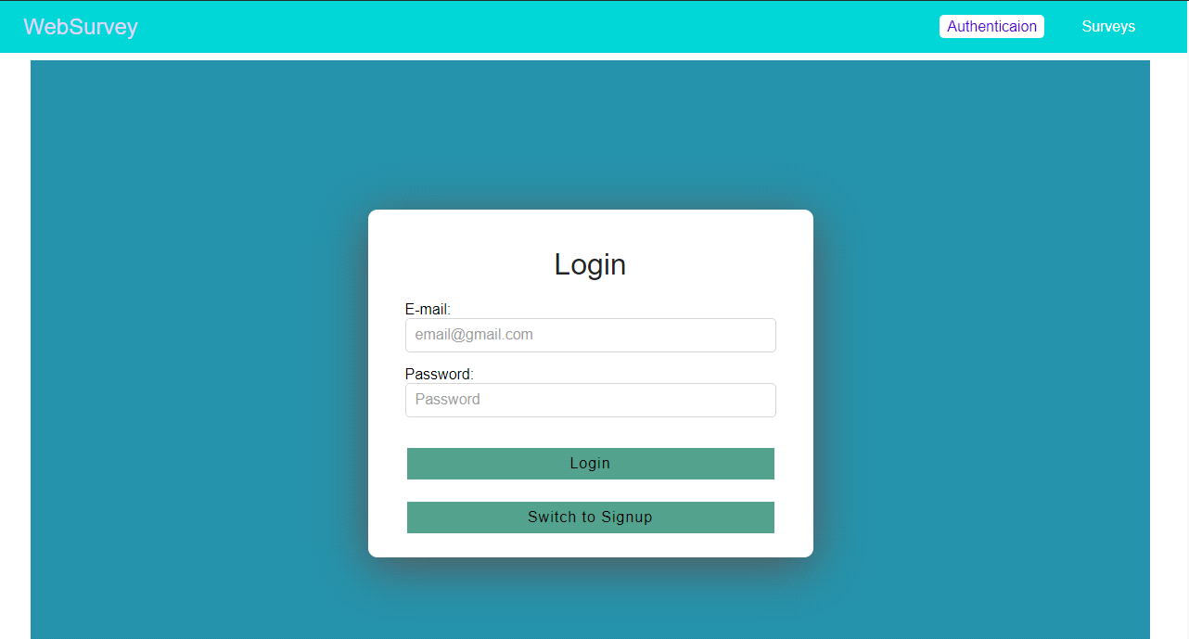

If the user is valid then page will be directed to the websurvey application.Here the user will be allowed to create the survey.



Here the survey details will be given.

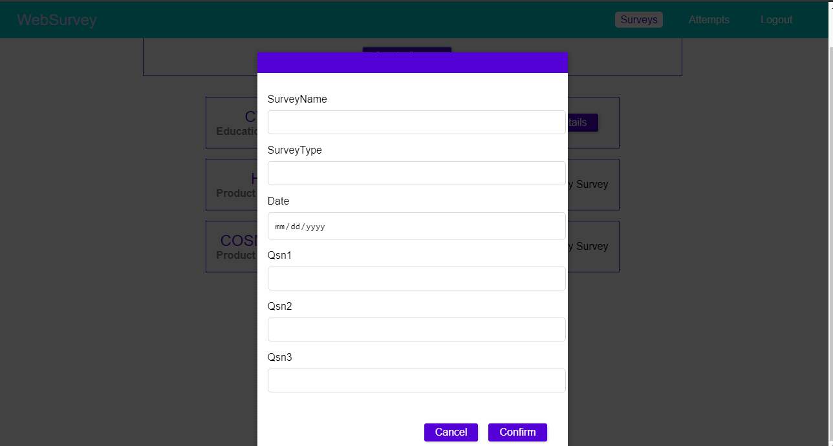

Here the user will be allowed to attempt the survey.

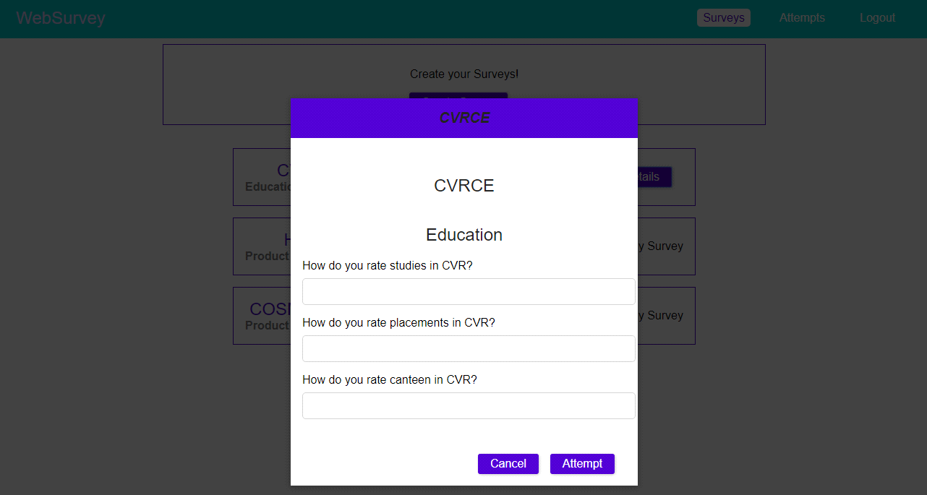

Here the survey details will be displayed in the form of list and graphs.

